Assignment 02 Results:

Input :

When Number of Student Records are 3.

Result:

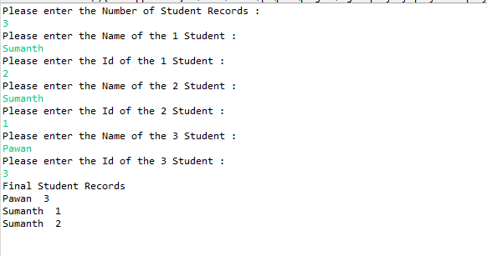

Input :

When Number of Student Records are 6.

Result:

